CS-405 Module Five: Static Code Analysis

By Justin Carlo Florida
Process Summary
For this activity, I used both Visual Studio and Cppcheck to perform static analysis on the provided questionable C++ code. I first compiled the code in Visual Studio and reviewed the Error List. Visual Studio successfully compiled the program but identified two warnings. I then imported the existing Visual Studio project into Cppcheck and performed a more extensive static analysis. Cppcheck identified significantly more issues than Visual Studio, including errors, warnings, style problems, and informational messages.
Visual Studio Analysis
Visual Studio identified two warnings. The first was C4297 on line 52 because the DontThrow function was declared noexcept but contained code that throws an exception. This is a risk because an exception escaping a noexcept function can cause the program to terminate unexpectedly. The issue can be mitigated by removing noexcept when exceptions are allowed or by changing the function so that an exception cannot escape.
The second warning was C4806 on line 129. Visual Studio identified an unsafe comparison where a Boolean value was being compared with an integer value that it could never equal. This can create incorrect program logic because a Boolean value should represent only true or false. The comparison should be rewritten so that the Boolean expression is evaluated appropriately.
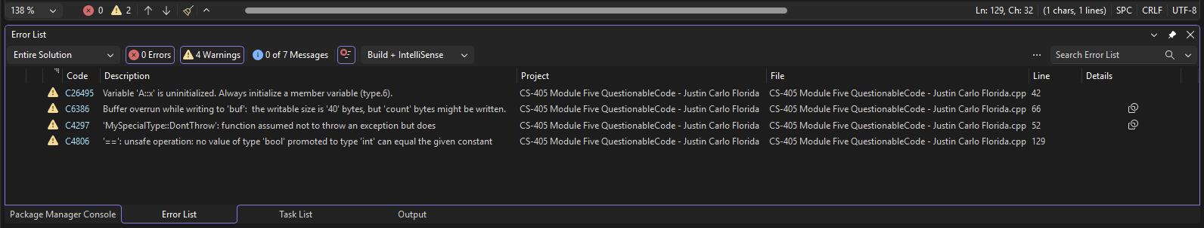Figure 1. Visual Studio Error List showing the warnings identified during compilation.

Cppcheck Analysis
Cppcheck found significantly more issues than Visual Studio. The major findings included an out-of-bounds array access, an invalid pointer to a local variable, a possible null-pointer dereference, an invalid iterator, an uninitialized member variable, and unsafe use of assert. These issues could cause crashes, undefined behavior, incorrect results, or security vulnerabilities. They can be mitigated by validating array indexes and pointers, properly initializing variables, safely managing iterators, and keeping operations with side effects outside of assertions.
Cppcheck also detected the noexcept exception problem and the Boolean comparison problem that Visual Studio identified. This showed that both tools could detect some of the same issues, but Cppcheck provided additional details and identified many problems that Visual Studio did not report.
Cppcheck also reported lower-risk code-quality issues, including unused functions and variables, variable shadowing, unnecessary variable scope, and functions that could be static. These findings are less serious than memory-safety problems, but correcting them can make the code easier to maintain and review.

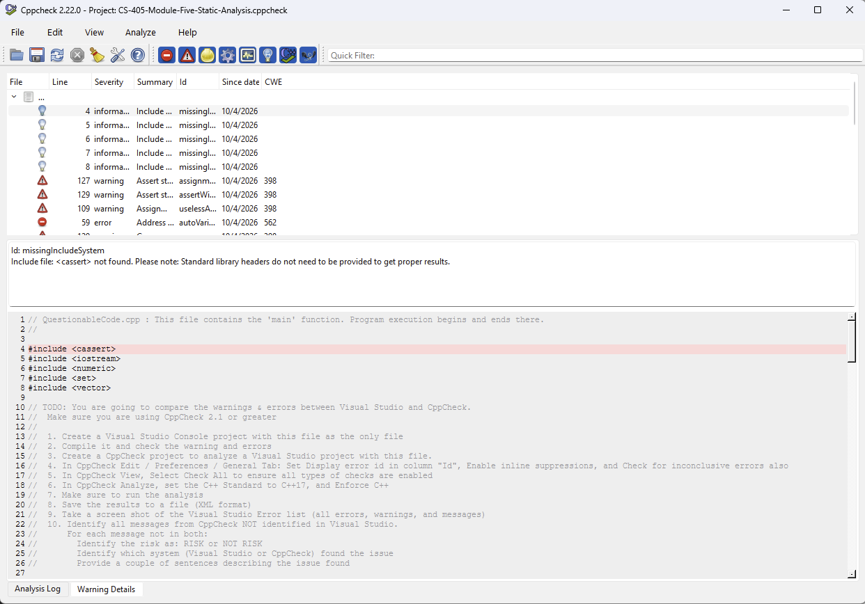Figure 2. Cppcheck results showing the issues identified during static analysis.

Comparison and Issues Not Identified
The comparison showed that Cppcheck performed a much deeper examination of the questionable code than the Visual Studio compiler warnings alone. Visual Studio identified two important problems during compilation, while Cppcheck identified those general problem areas along with additional memory-safety, pointer, iterator, initialization, assertion, and code-quality concerns. The Cppcheck report also included informational messages stating that several standard library include files were not found. Cppcheck itself noted that these headers were not required to obtain proper analysis results.
Some questionable coding constructs in the provided code were not reported as separate findings by either Visual Studio or Cppcheck. This demonstrates an important limitation of automated static analysis. A tool only reports problems that its rules and analysis are designed to recognize. Developers still need manual code reviews, testing, secure coding standards, and other security practices to identify problems that automated tools may overlook. Static analysis should therefore be used as one layer of a defense-in-depth development process rather than as the only method of finding vulnerabilities.
Conclusion
This activity demonstrated the benefit of using more than one static analysis method. Visual Studio provided useful compiler warnings, but Cppcheck identified a much broader range of potential defects and security risks. The most significant Cppcheck findings involved unsafe memory access, invalid pointers, possible null-pointer dereferencing, iterator invalidation, exception handling, and incorrect assertion usage. Using static analysis early in development allows developers to identify these problems before software is released. Combining compiler warnings, dedicated static analysis tools, manual review, and testing provides stronger protection than relying on a single tool.

